***SERVICENOW PROJECT***

***LAPTOP REQUEST CATALOG ITEM***

*Creating Local Update Set :*

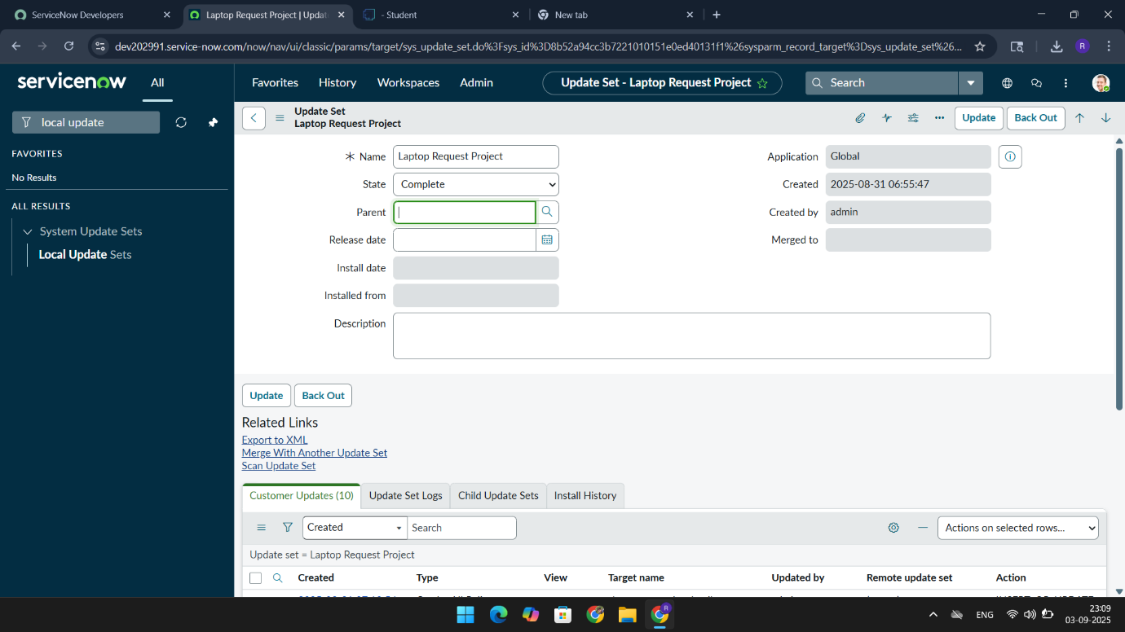

*Creating Service Catalog Item :*

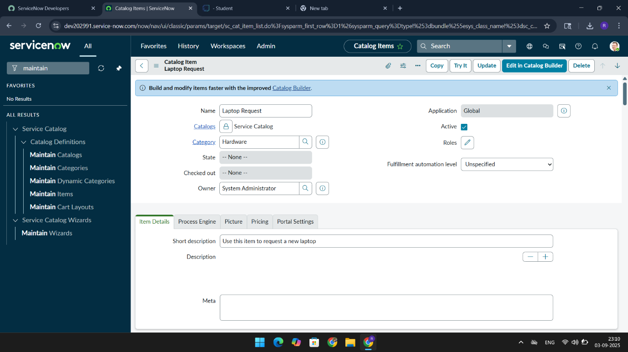

*Adding Variables in catalog :*

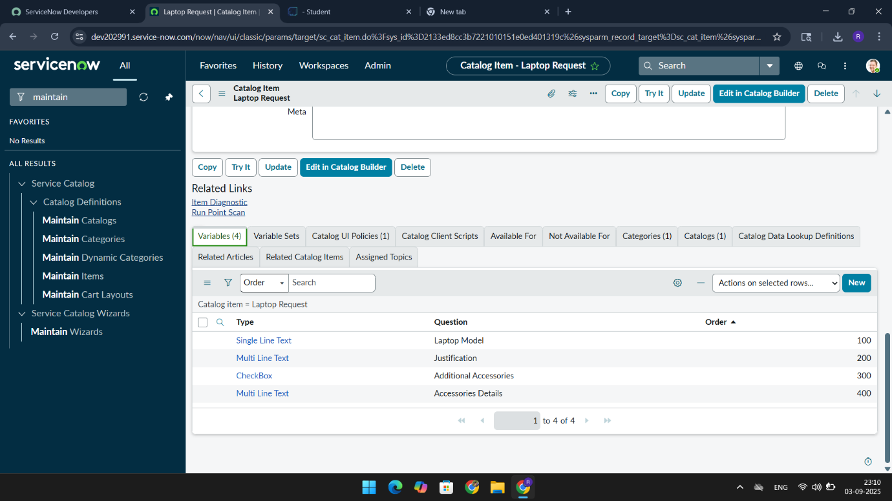

*Creating Catalog UI Policies :*

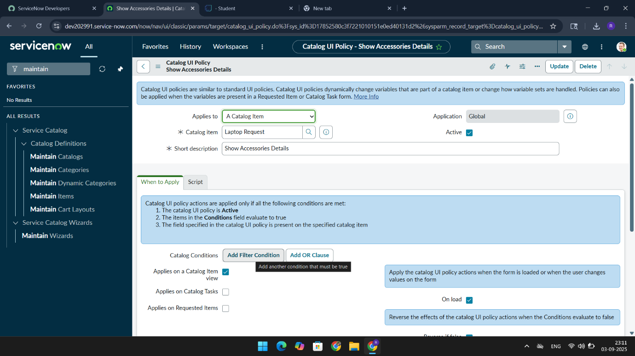

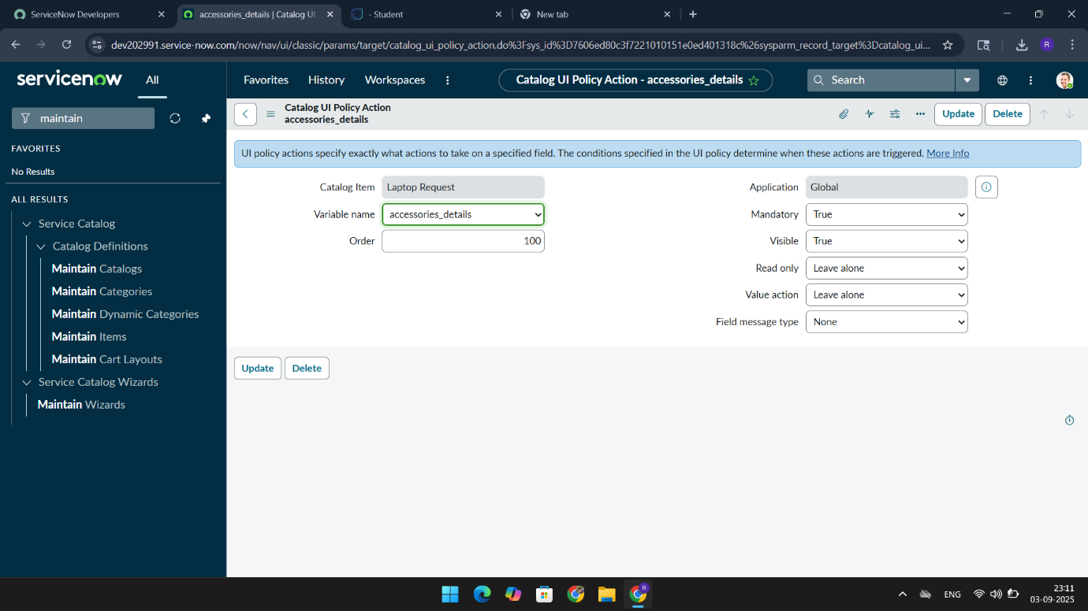

*Creating UI action :*

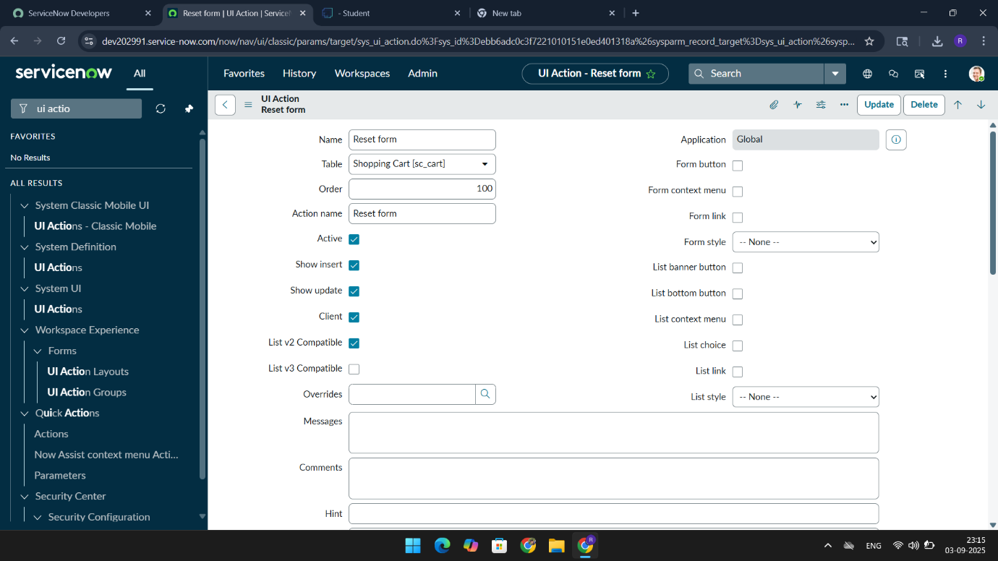

*Exporting Update set :*

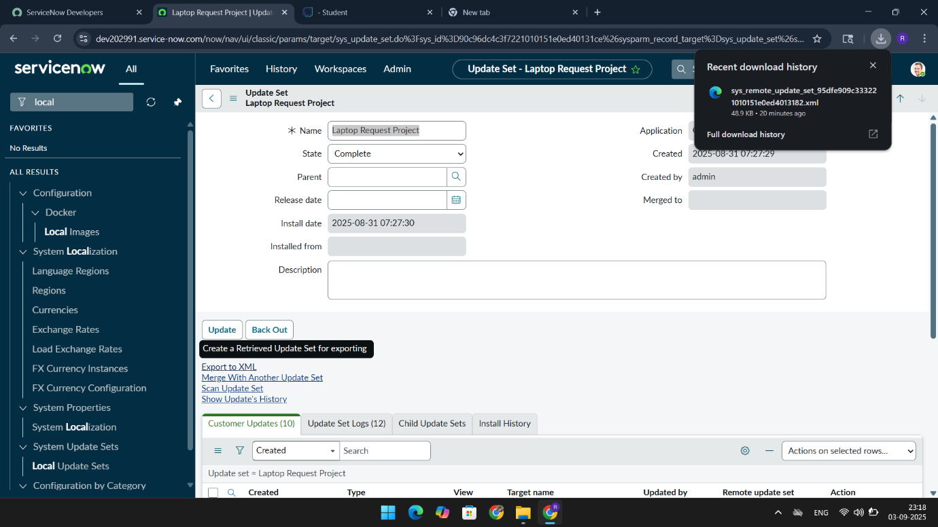

*Retrieving the Update Set:*

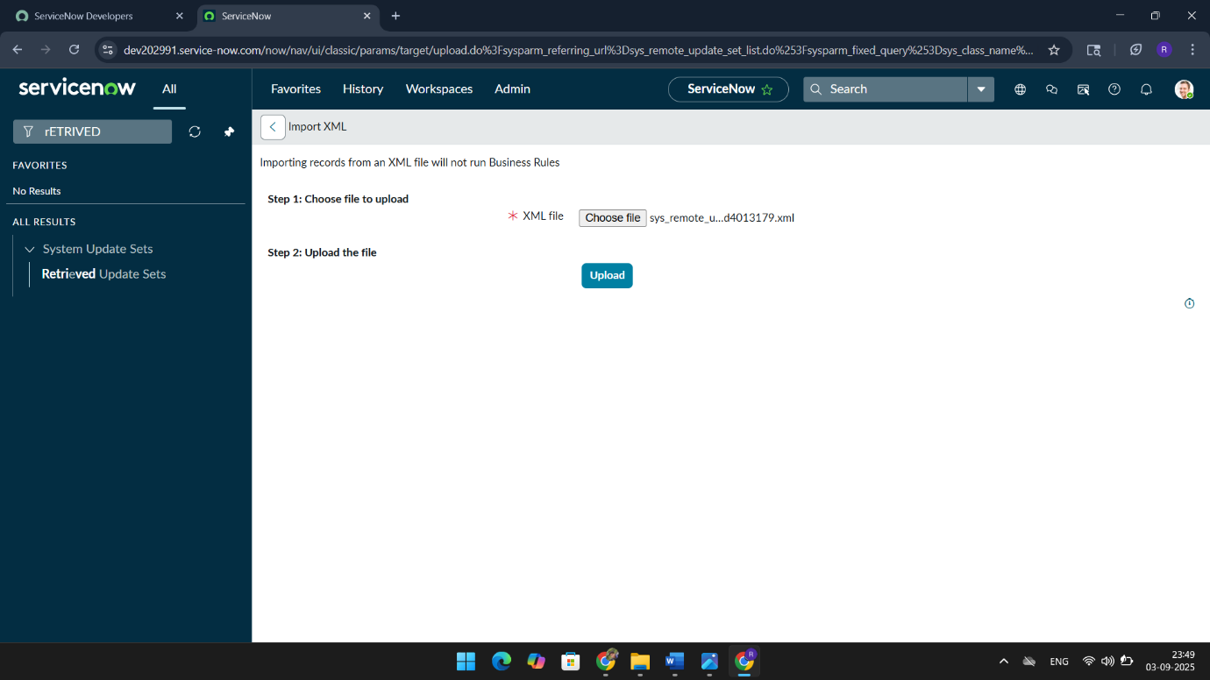

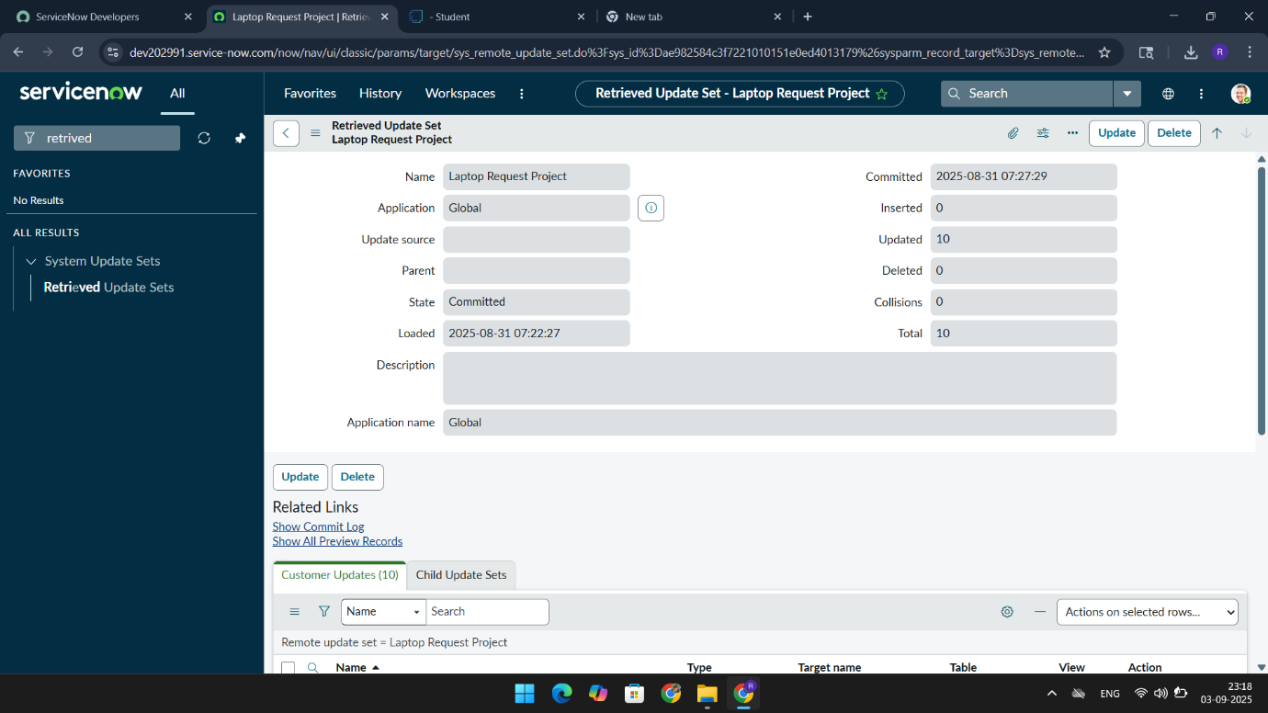

*Testing:*

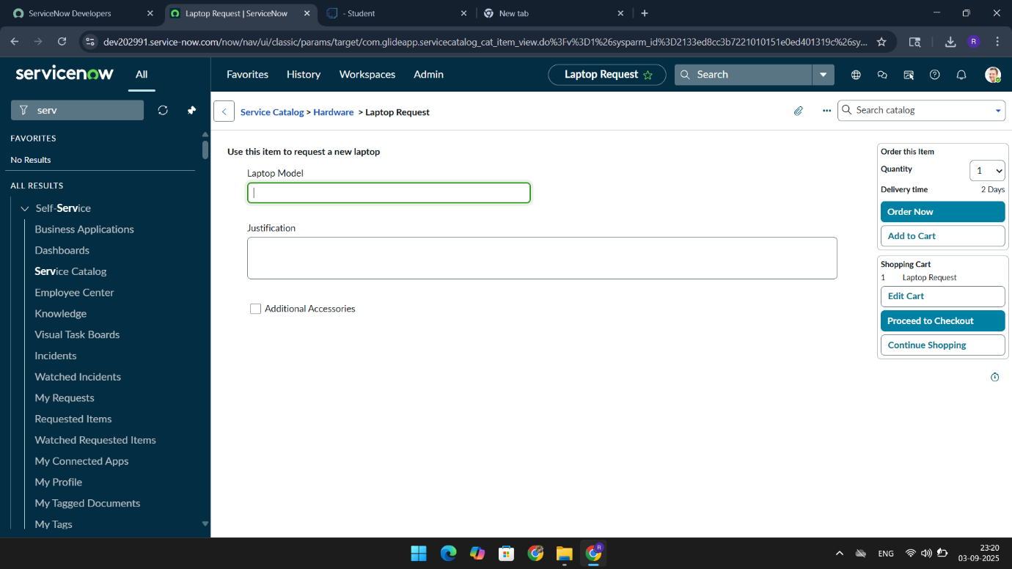

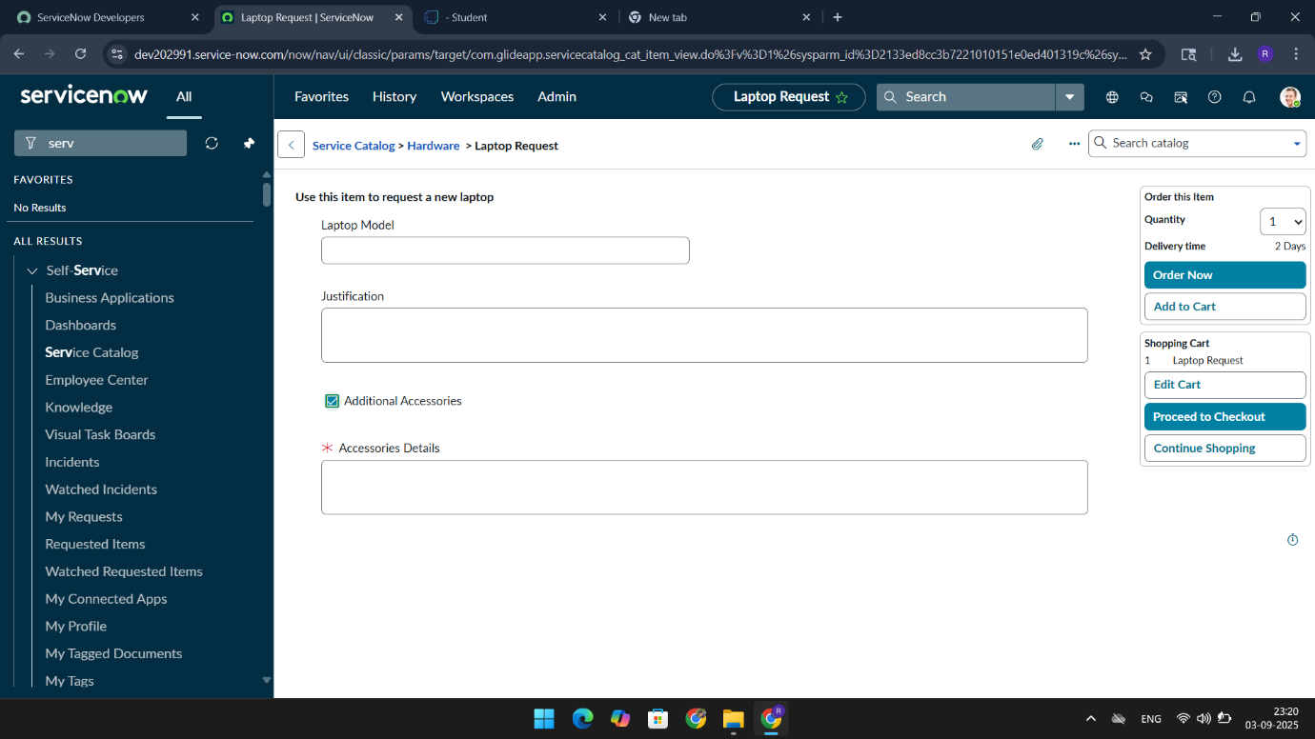

*“Finally project has been completed successfully”*